Accessing the JADARA online

Depending on whether your institution subscribes to JADARA or whether you are an individual member, there will be different steps to access content in the journal. Please follow the steps according to your membership subscription below. Note that recently published content in the journal in the first 120 days is only available to ADARA members, while older articles is available to all visitors.

Institutional subscribers
If your institution's library subscribes to JADARA, simply visit the journal homepage below when you are on-campus, and you should be granted access to all materials on the site:

http://repository.wcsu.edu/jadara

If you are off-campus and you need to access the journal, you will need to work with your library to set up proxy access.

If you encounter any difficulty, please contact us with the name of your institution.

Individual Subscribers
If you are an individual member of ADARA, simply follow Steps 1-6 below to set up your new account and access all materials in the journal for the first time. Once your new account is set up, you only need to follow Step 7 to access all material in the journal.

1. Visit the journal homepage below:
http://repository.wcsu.edu/jadara

2. Click the "My Account" link near the top of the page.

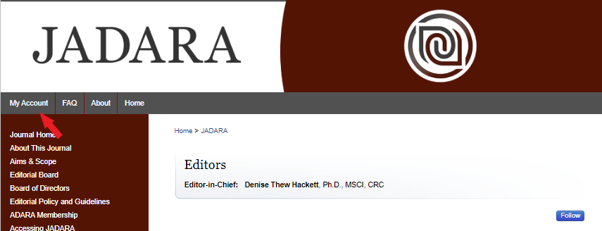

3. Under the "Login” box, click "Sign up" to begin setting up an account.

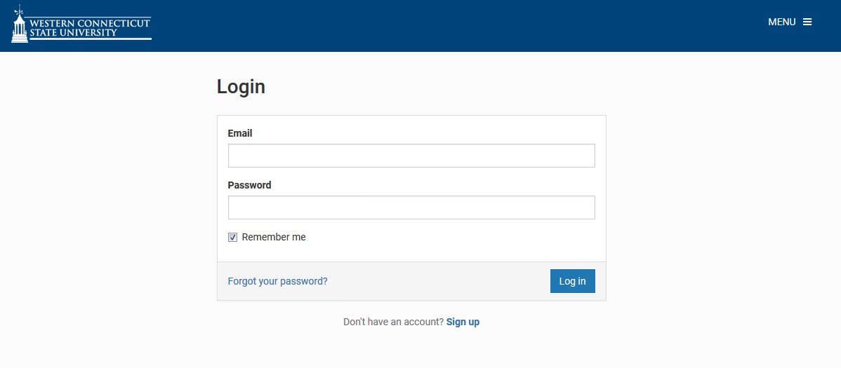

4. On the resulting screen, enter the email address associated with your ADARA membership, your first name, your last name, your affiliation (if any), and create a password that you will use to access material in the future, and click the "Create Account” button.

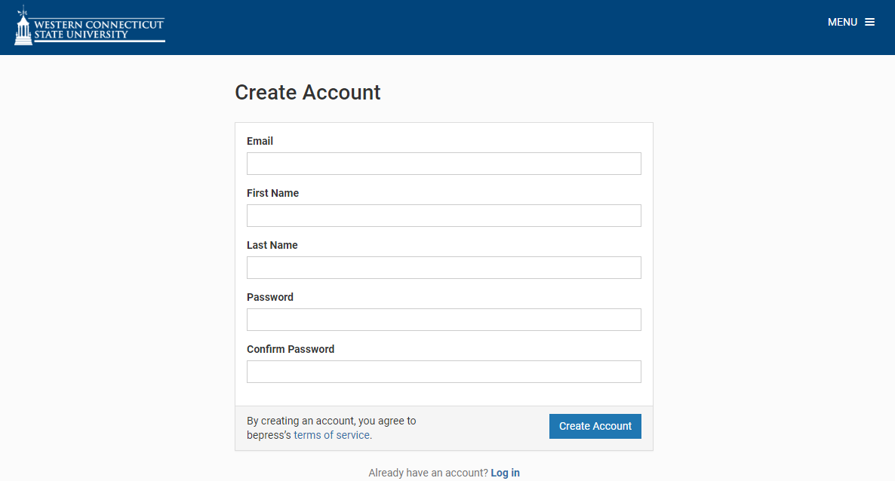

5. After clicking “Create Account”, the screen will indicate that you are about to receive an account activation link. The email will come from the email address noreply@bepress.com. It will ask you to click the green “Confirm Account” button in the email to confirm your email address and account. Click the link.

Note: Below is a sample confirmation email. Your own email provider may appear differently, but the body of the message should remain the same. If you do not receive the email in your Inbox, please check your Junk or Spam email folder. If you still do not find it after waiting a few minutes, please contact dc-support@bepress.com or call (510)665-1200, option 2 for assistance.

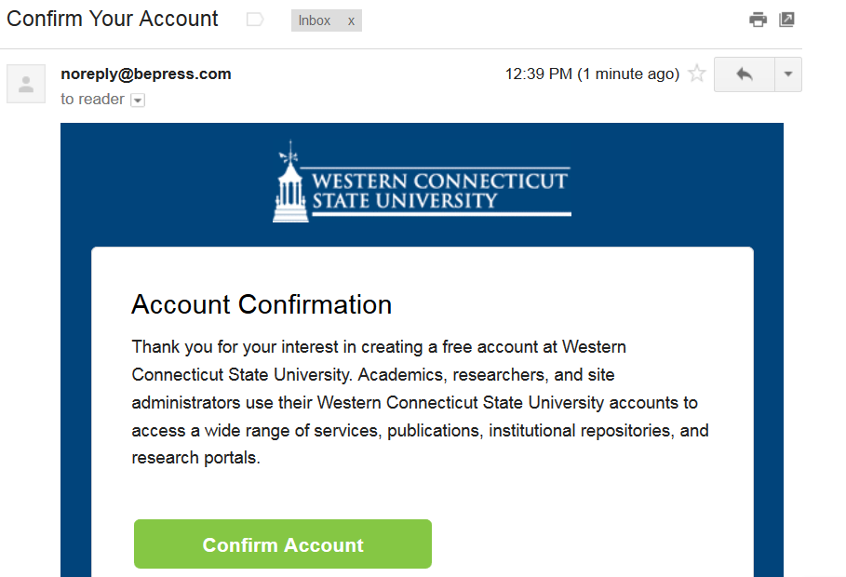

6. After clicking Confirm Account button, your account will have been successfully created and confirmed. You will be directed to your new My Account page in the journal.

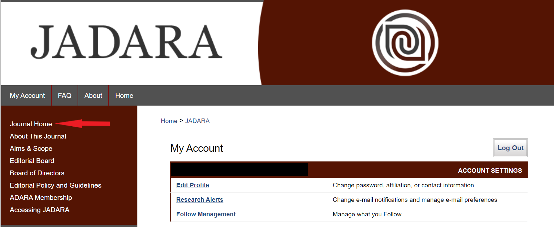

On the journal homepage at http://repository.wcsu.edu/jadara/, you will find the most recently published issue. Past issues can be accessed from the sidebar menu “Select an issue”. Since you are already logged into the new journal’s homepage, you will have access to all content in the journal. From the homepage, you can click on the “PDF” icon next to an article to download the article or you can click on the title of a paper to view its details first.

7. You only need to set up an account the first time you access the journal (Steps 1-6 above). After your account is set up, you can use the account details you established (your email and password) to login to the journal and access content in the future.

To do so, simply visit the journal homepage at http://repository.wcsu.edu/jadara, click the “My Account” link near the top of the page, and log in with the email and password you established. Once you’re logged in, you can visit the Journal Home and access all content.

If you encounter any difficulty after following these steps, please contact dc-support@bepress.com or 510-665-1200, option 2 with your name and the email address associated with your account.

